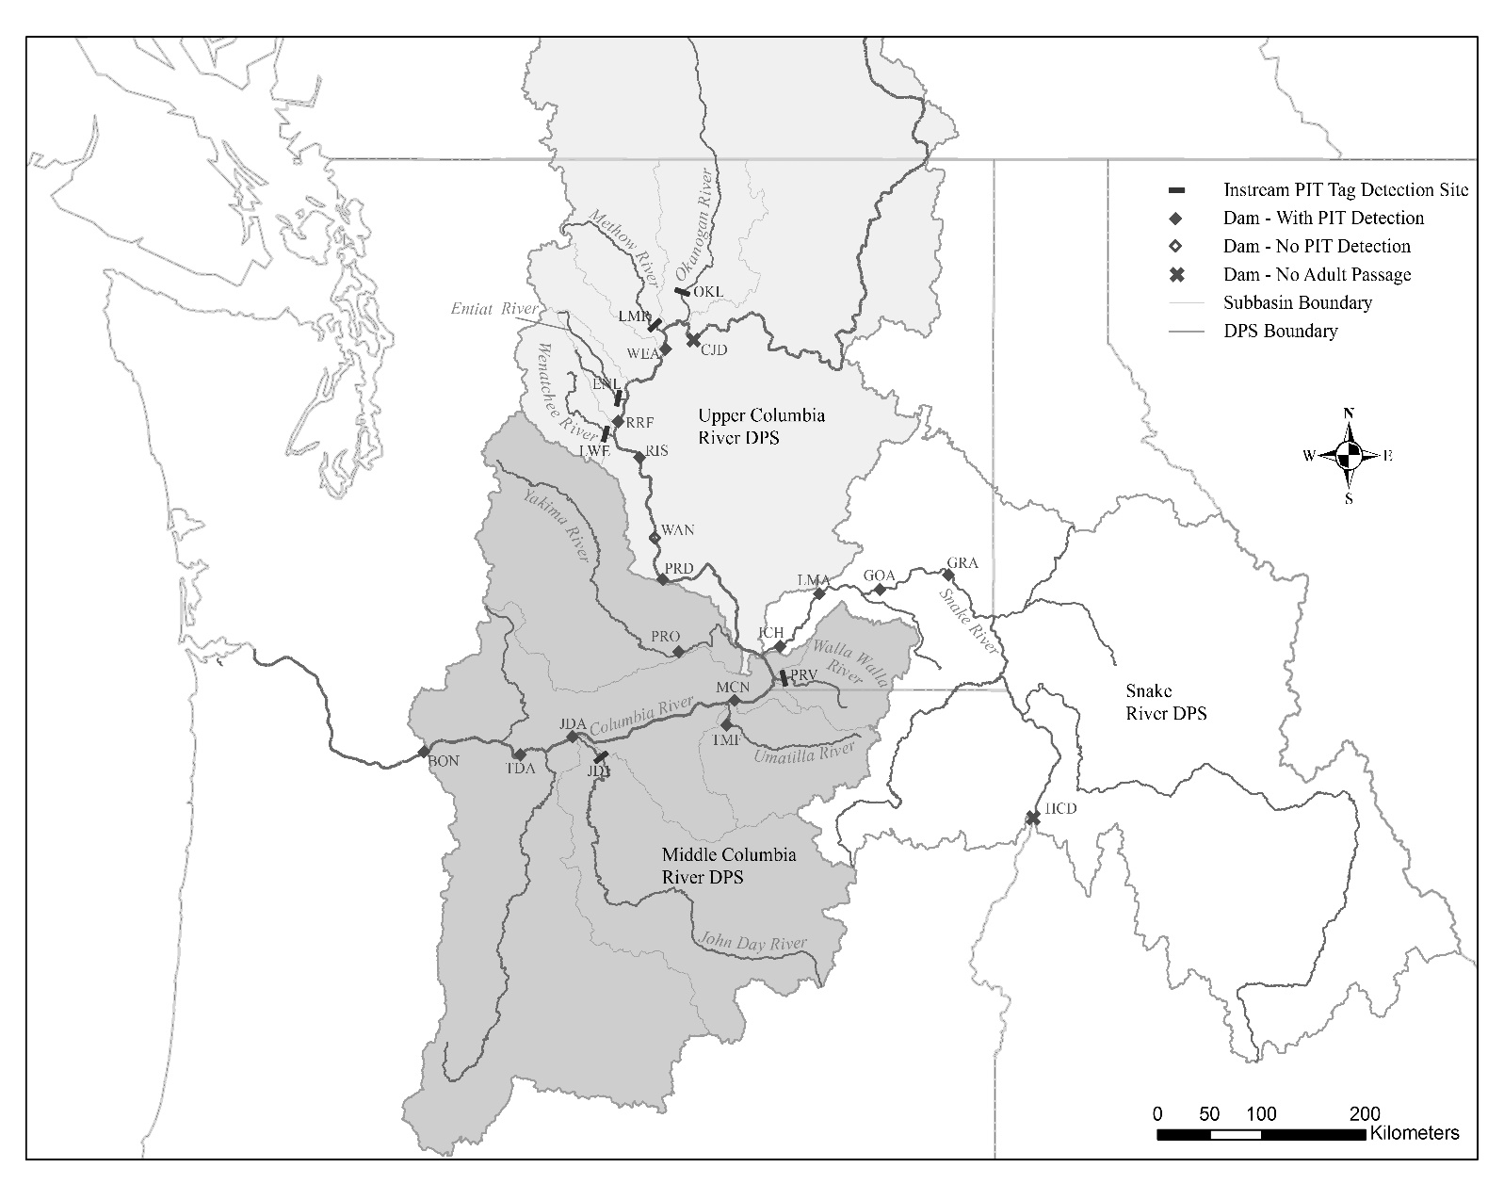

Figure 1. Vicinity map of steelhead distinct population segments (DPS), major rivers and dams, and instream PIT tag detection locations on the Columbia and Snake Rivers. BON = Bonneville Dam, TDA = the Dalles Dam, JDA = John Day Dam, JD1 = Lower John Day River IPDS, TMF = Three Mile Falls Dam, MCN = McNary Dam, PRV = Lower Walla Walla River IPDS, ICH = Ice Harbor Dam, LMA = Lower Monumental Dam, GOA = Little Goose Dam, GRA = Lower Granite Dam, HCD = Hells Canyon Dam, PRO = Prosser Dam, PRD = Priest Rapids Dam, WAN = Wanapum Dam, RIS = Rock Island Dam, LWE = Lower Wenatchee river IPDS, RRF = Rocky Reach Dam, ENL = Lower Entiat River IPDS, WEA = Wells Dam, LMR = Lower Methow River IPDS, OKL = Lower Okanogan River IPDS, CJD = Chief Joseph Dam.

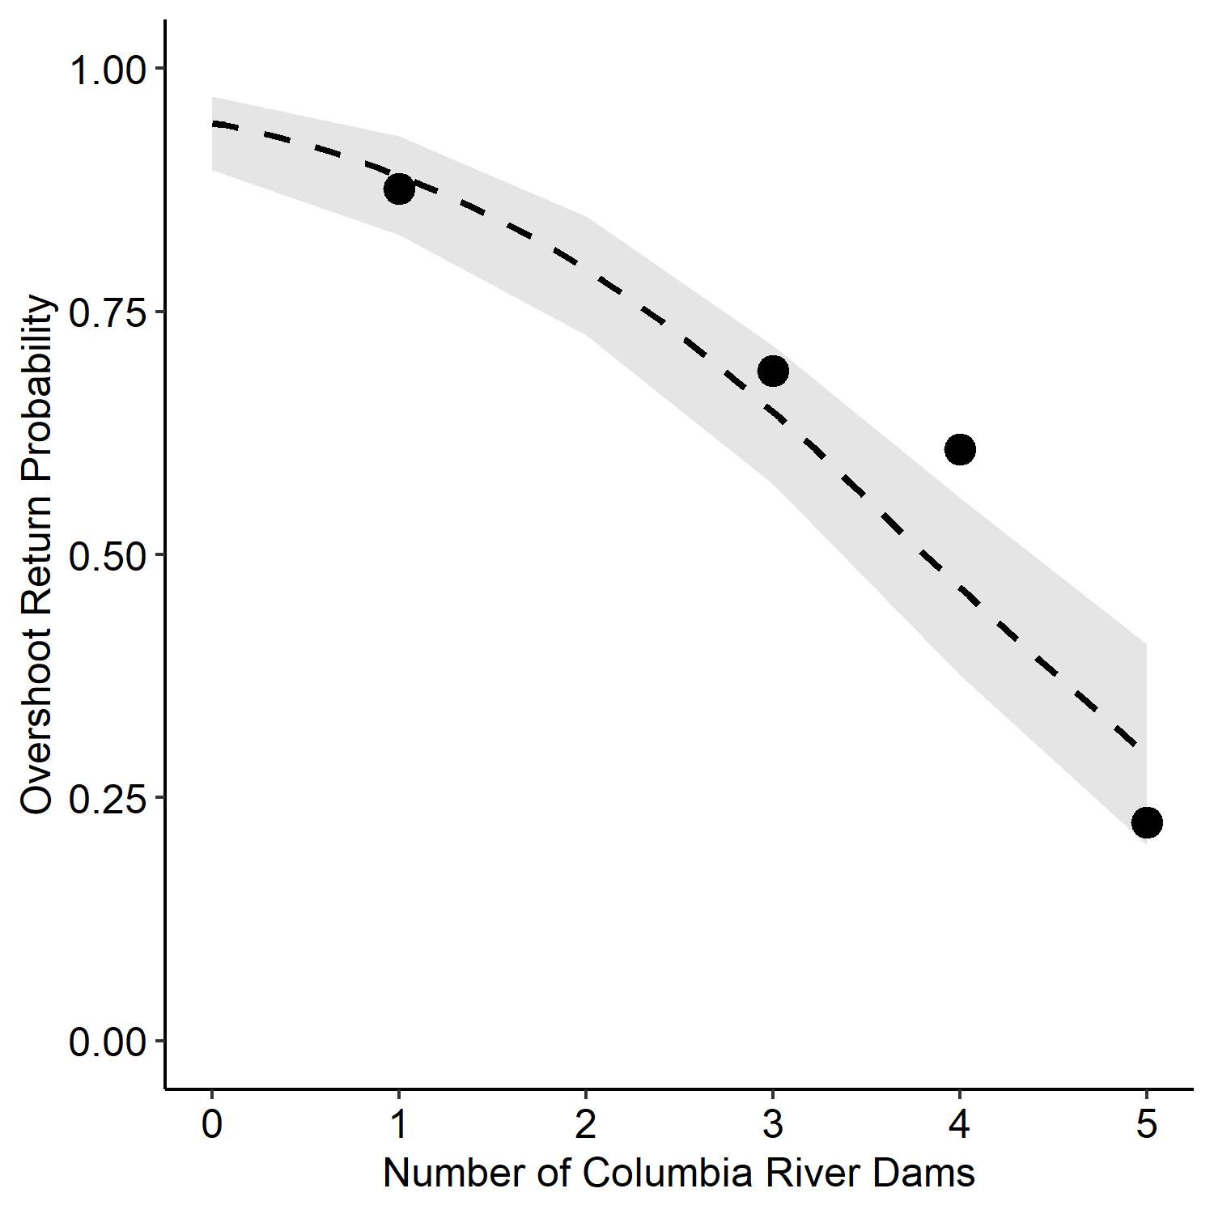

Figure 2. Logistic regression between the number of dams to the furthest upstream detection location for known origin overshoot steelhead detected at Priest Rapids Dam and the overshoot fallback proportion detected downstream of Priest Rapids Dam, 2010-2017.

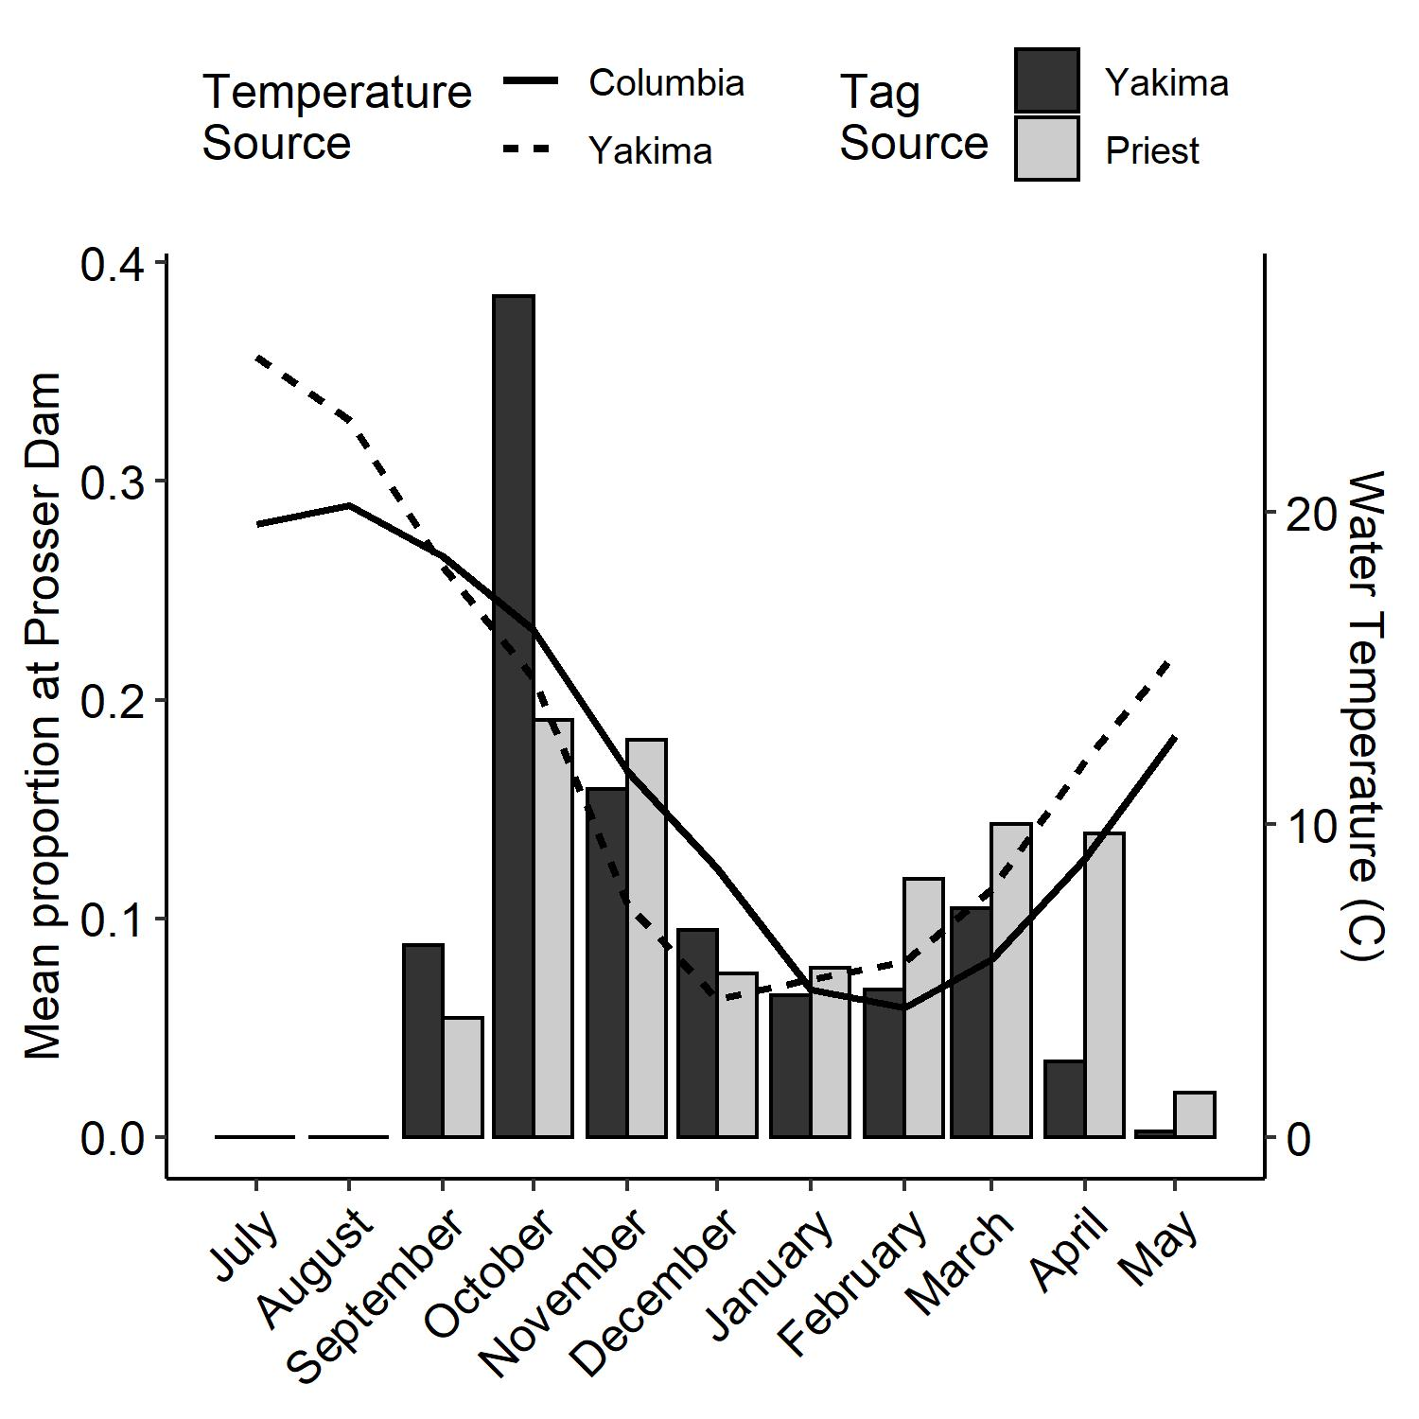

Figure 3. Passage timing of steelhead tagged as juveniles in the Yakima, and fish tagged as adults at Priest who were detected at Prosser Dam in the lower Yakima River, 2010-2017. Mean monthly water temperatures (2015-2016) measured in the lower Yakima River at Kiona (rkm 48) and Columbia River measured at Priest Rapids Dam tailrace.

Figure 4. The distribution of overshoot wild steelhead (N = 559) from the Middle Columbia River distinct population segment in the Upper Columbia River (Priest Rapids Dam) and Snake River (Ice Harbor Dam) distinct population segments, 2010-2017.